Day2

1) Alter Table:

* Add a new column linkedin_profile to employees table to store LinkedIn URLs as varchar.

ALTER TABLE employees

ADD COLUMN linkedin_profile VARCHAR (200)

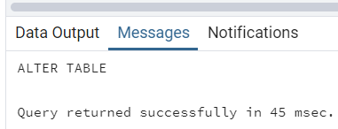

* Change the linkedin_profile column data type from VARCHAR to TEXT.

ALTER TABLE employees

ALTER COLUMN linkedin_profile TYPE TEXT

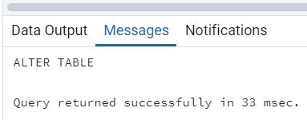

* Add unique, not null constraint to linkedin_profile

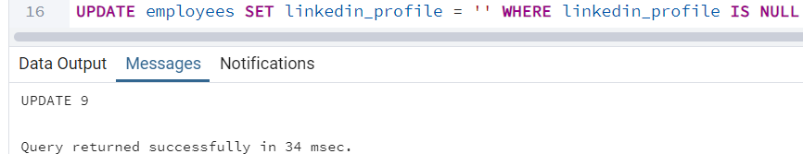

UPDATE employees

SET linkedin_profile = 'https://www.linkedin.com/us/Nancy'

WHERE employeeID = 1

UPDATE employees SET linkedin_profile = 'https://www.linkedin.com/us/Andrew'

WHERE employeeID = 2

UPDATE employees SET linkedin_profile = 'https://www.linkedin.com/us/Janet'

WHERE employeeID = 3

UPDATE employees SET linkedin_profile = 'https://www.linkedin.com/us/Margaret'

WHERE employeeID = 4

UPDATE employees SET linkedin_profile = 'https://www.linkedin.com/us/Steven'

WHERE employeeID = 5

UPDATE employees SET linkedin_profile = 'https://www.linkedin.com/us/Michael'

WHERE employeeID = 6

UPDATE employees SET linkedin_profile = 'https://www.linkedin.com/us/Robert'

WHERE employeeID = 7

UPDATE employees SET linkedin_profile = 'https://www.linkedin.com/us/Laura'

WHERE employeeID = 8

UPDATE employees SET linkedin_profile = 'https://www.linkedin.com/us/Anne'

WHERE employeeID = 9

ALTER TABLE employees

ALTER COLUMN linkedin_profile SET NOT NULL

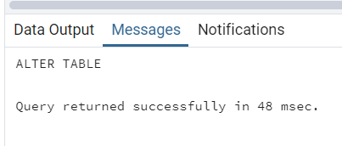

ALTER TABLE employees

ADD CONSTRAINT "unique_linkedin_profile" UNIQUE (linkedin_profile)

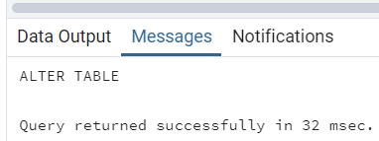

* Drop column linkedin_profile

ALTER TABLE employees

DROP COLUMN "linkedin_profile"

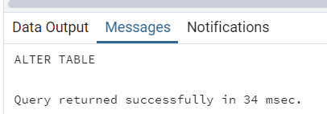

2) Querying (Select)

* Retrieve the employee name and title of all employees

SELECT employeeName, title

FROM employees

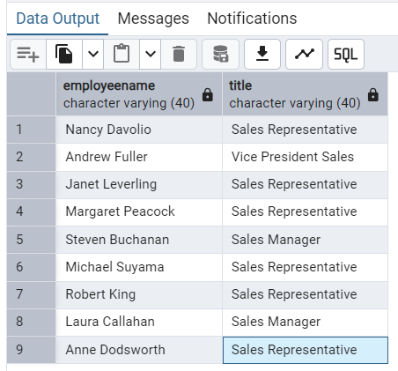

* Find all unique unit prices of products

SELECT DISTINCT unitPrice

FROM products

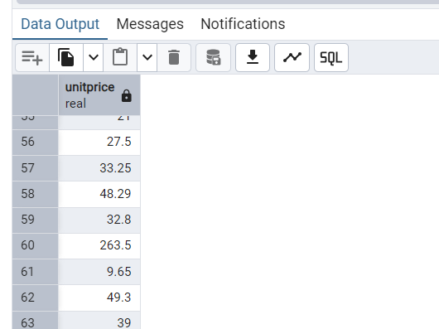

* List all customers sorted by company name in ascending order

SELECT companyName

FROM customers

ORDER BY companyName ASC

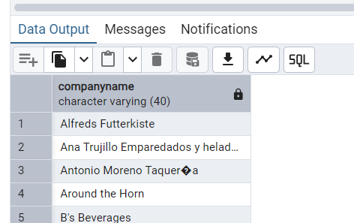

* Display product name and unit price, but rename the unit_price column as price_in_usd

SELECT productName,unitPrice AS price_in_usd

FROM products

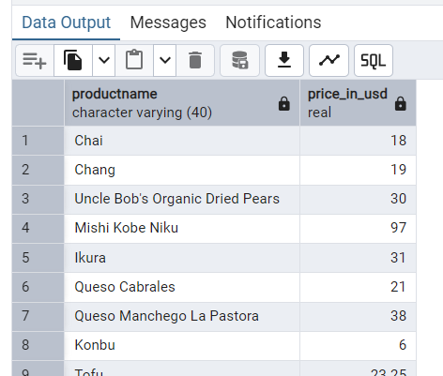

3) Filtering

* Get all customers from Germany.

SELECT * FROM customers

WHERE country = 'Germany'

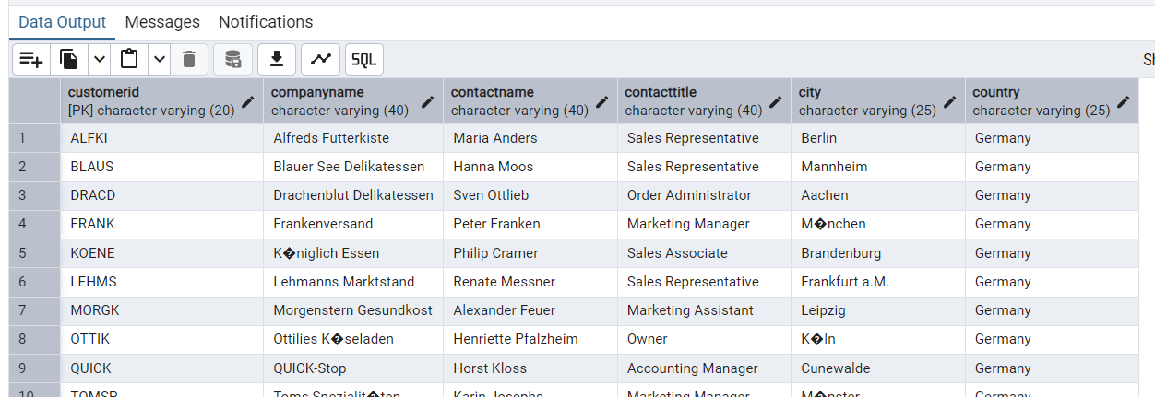

* Find all customers from France or Spain

SELECT * FROM customers

WHERE country = 'France' OR country ='Spain'

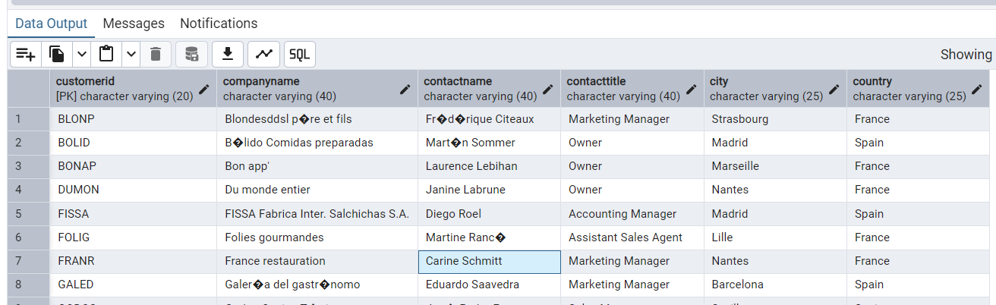

* Retrieve all orders placed in 2014(based on order_date), and either have freight greater than 50 or the shipped date available (i.e., non-NULL) (Hint: EXTRACT(YEAR FROM order_date))

SELECT * FROM orders

WHERE EXTRACT(YEAR FROM orderDate) = 2014

AND (frieght > 50 OR shipperDate IS NOT NULL)

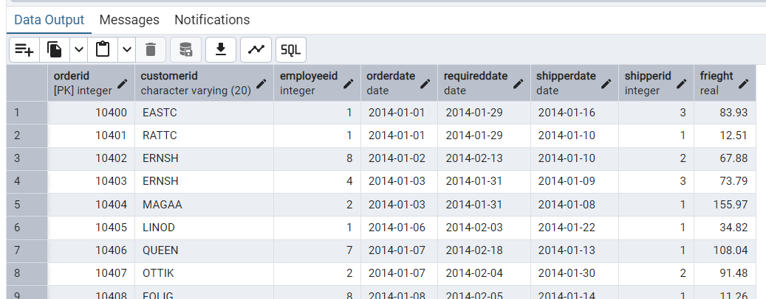

4) Filtering

* Retrieve the product_id, product_name, and unit_price of products where the unit_price is greater than 15.

SELECT productID, productName, unitPrice

FROM products

WHERE unitPrice > 15

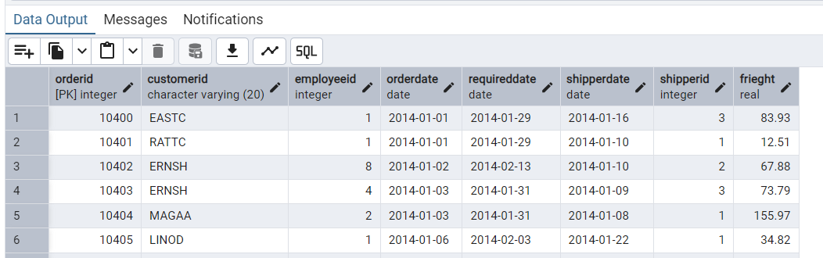

* List all employees who are located in the USA and have the title "Sales Representative".

SELECT * FROM employees

WHERE country = 'USA' AND title = 'Sales Representative'

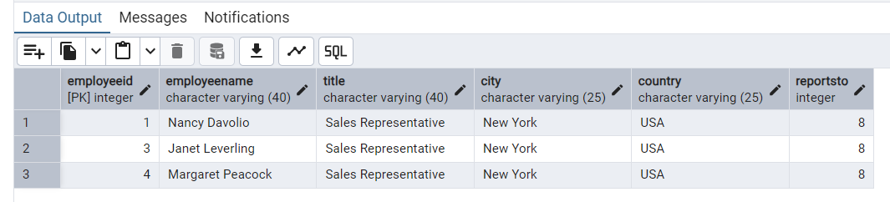

* Retrieve all products that are not discontinued and priced greater than 30.

SELECT * FROM products

WHERE discontined = 0 AND unitPrice > 30;

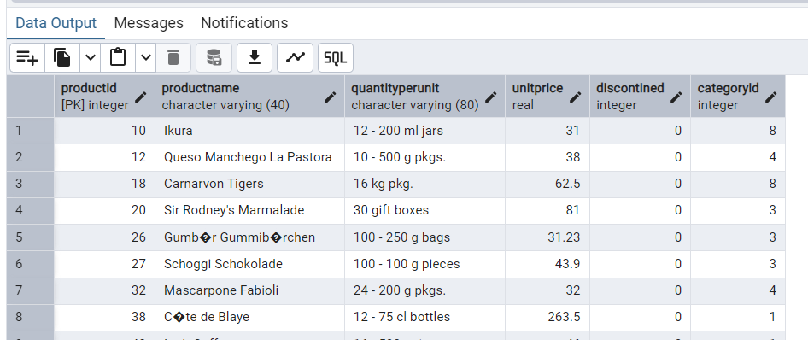

5) LIMIT/FETCH

* Retrieve the first 10 orders from the orders table.

SELECT * FROM orders

LIMIT 10;

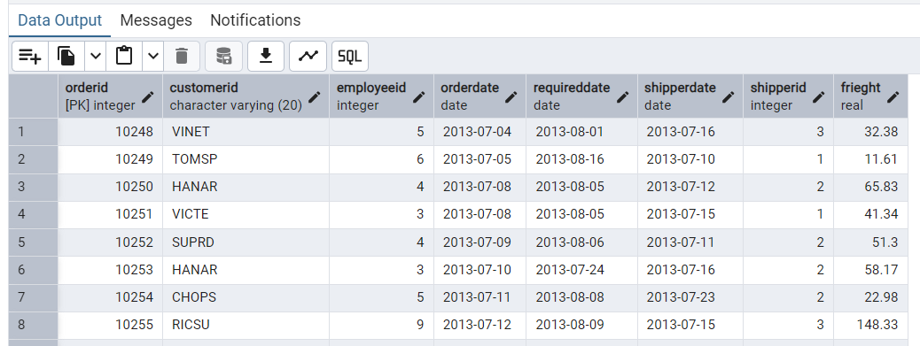

* Retrieve orders starting from the 11th order, fetching 10 rows (i.e., fetch rows 11-20).

SELECT * FROM orders

ORDER BY orderID

OFFSET 10

LIMIT 10;

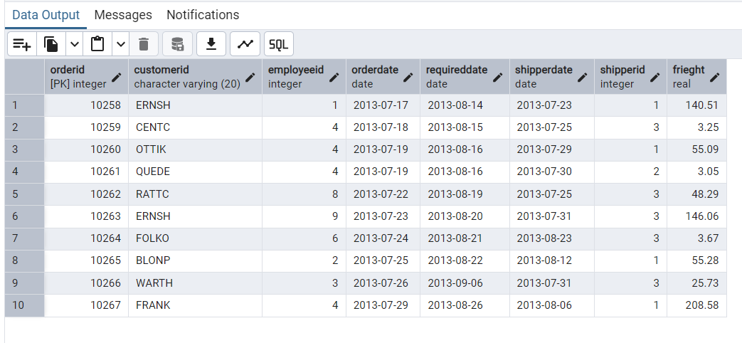

6) Filtering (IN, BETWEEN)

* List all customers who are either Sales Representative, Owner

SELECT * FROM customers

WHERE contactTitle IN ('Sales Representative','Owner')

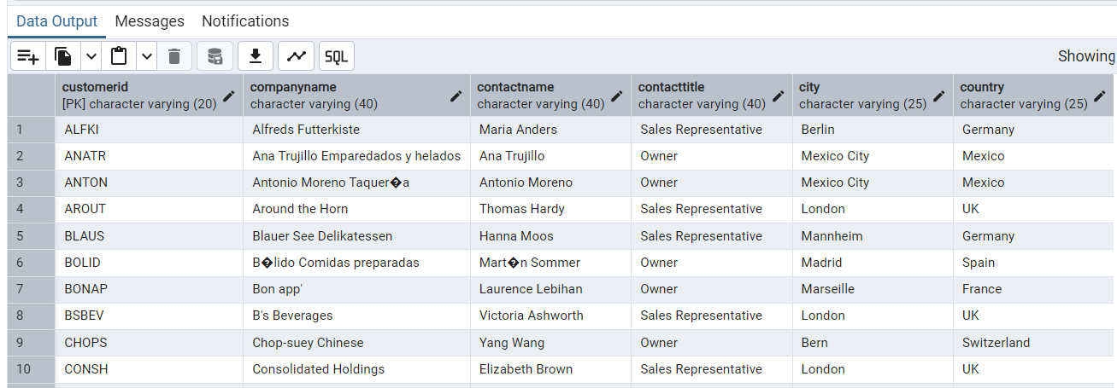

* Retrieve orders placed between January 1, 2013, and December 31, 2013.

SELECT * FROM orders

WHERE orderDate BETWEEN '2013-01-01' AND '2013-12-31'

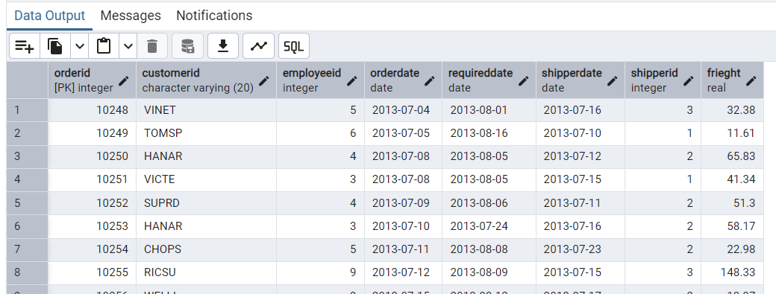

7) Filtering

* List all products whose category_id is not 1, 2, or 3.

SELECT * FROM products

WHERE categoryID NOT IN (1,2,3)

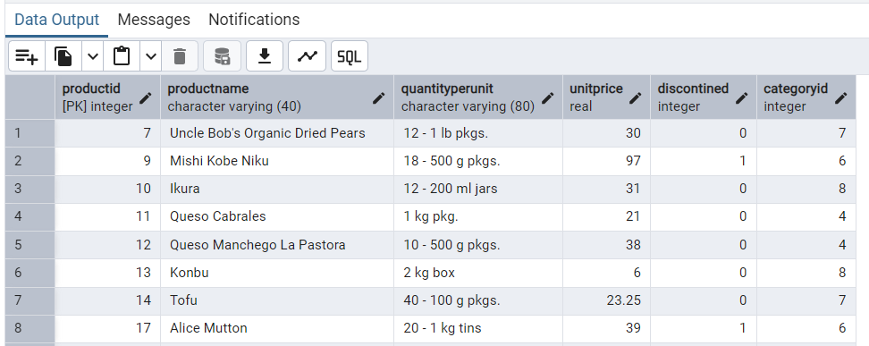

* Find customers whose company name starts with "A".

SELECT * FROM customers

WHERE companyName LIKE 'A%'

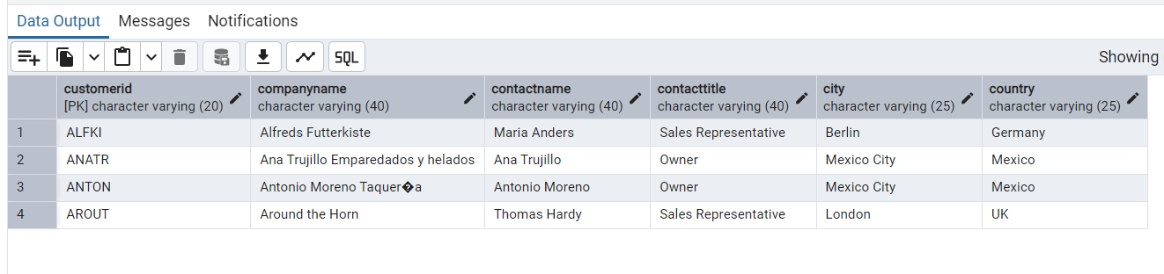

8) INSERT into orders table:

Task: Add a new order to the orders table with the following details:

Order ID: 11078

Customer ID: ALFKI

Employee ID: 5

Order Date: 2025-04-23

Required Date: 2025-04-30

Shipped Date: 2025-04-25

shipperID:2

Freight: 45.50

INSERT INTO orders (orderID, customerID, employeeID, orderDate, requiredDate, shipperDate, shipperID, frieght)

VALUES( 11078,'ALFKI', 5, '2025-04-23', '2025-04-30', '2025-04-25', 2,45.50

)

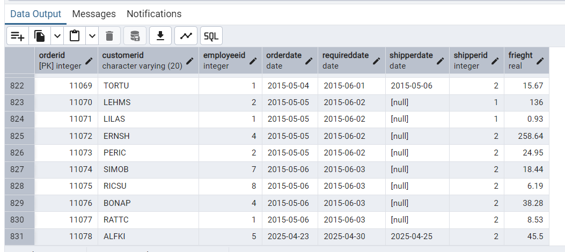

9) Increase(Update) the unit price of all products in category_id =2 by 10%.

(HINT: unit_price =unit_price * 1.10)

10) Sample Northwind database:

Download

1. Download northwind.sql from below link into your local. Sign in to Git first <https://github.com/pthom/northwind_psql>
2. Manually Create the database using pgAdmin:
   1. Right-click on "Databases" → Create → Database
   2. Give name as ‘northwind’ (all small letters)
   3. Click ‘Save’

Import database:

1. Open pgAdmin and connect to your server
2. Select the database ‘northwind’
3. Right Click-> Query tool.
4. Click the folder icon to open your northwind.sql file
5. Press F5 or click the Execute button.
6. You will see total 14 tables loaded
7. Databases → your database → Schemas → public → Tables

